## **Objectives**

* Explain React State

In this hands-on lab, you will learn how to:

* Use React State object

## **Prerequisites**

The following is required to complete this hands-on lab:

* Node.js
* NPM
* Visual Studio Code

## **Notes**

Estimated time to complete this lab: **60 minutes.**

Create a React App “counterapp” which will have a component named “CountPeople” which will have 2 methods.

UpdateEntry() 🡪 which will display the number of people who entered the mall.

UpdateExit() 🡪 which will display the number of people who exited the mall.

Use Constructor and state to Store the entrycount and exitcount.

The component has 2 buttons

1. Login 🡪 when clicked, the entrycount should get incremented by 1
2. Exit 🡪 when clicked, the exitcount should get incremented by 1

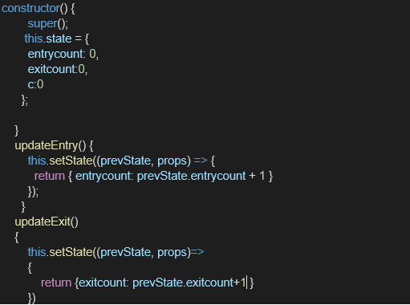

The output should be as follows:

